|  |  |
| --- | --- |
| **Arduino Controlled Micro-Pump**  **Prototyping Protocol** | **ID: PP-1** |

**Date Written –** 4/5/2020

**Date Revised –** 4/6/2020

**Authors: Odalis Castro, Meaza Feyso, Serena Kishek, Cassie Salem**

**Protocol Description – (Bioreactor Pump/Prototyping the Micro-Pump for the Bioreactor)**

The use of a printed circuit board (PCB) eliminated the need to use a breadboard and wires to establish the circuit required to drive the stepper motor system that runs the bioreactor. The PCB created is an Arduino Uno compatible shield. This shield contains all the electrical components required to run the bioreactor pump and fits onto the top of an Arduino Uno. This design modification allowed for the electrical circuit to be neatly localized allowing for space.

The diagram illustrated in Figure 1 is the schematic that contains all the electrical components necessary to run the bioreactor pump system. This schematic accurately represents the components needed and the manner in which to wire them to achieve a functioning circuit. Furthermore, this schematic is used to generate the board file to create the PCB.

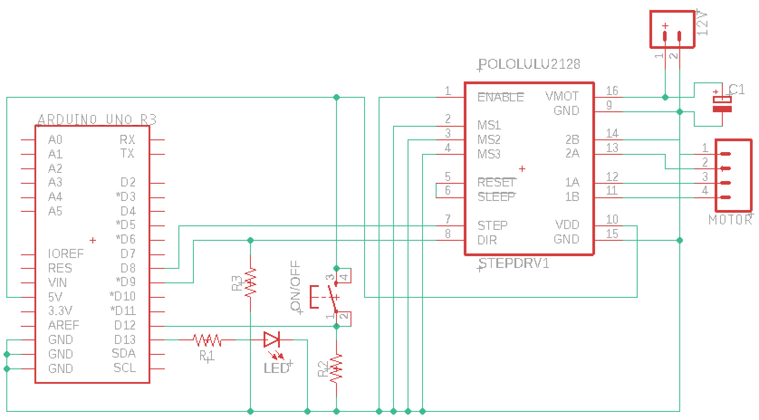

**Figure 1.** Bioreactor Pump Circuit Schematic

The diagram illustrated by Figure 2 is the board file used to generate the PCB for the bioreactor pump. As shown in the board layout, the PCB shield is complementary to an Arduino Uno and houses all the necessary electrical components. The board file was arranged in a compact manner. The spaces on the PCB allows for the rearrangement and addition of other components as required by the system. The PCB also allows for all the electrical components to be soldered directly onto it, eliminating the need for wires.

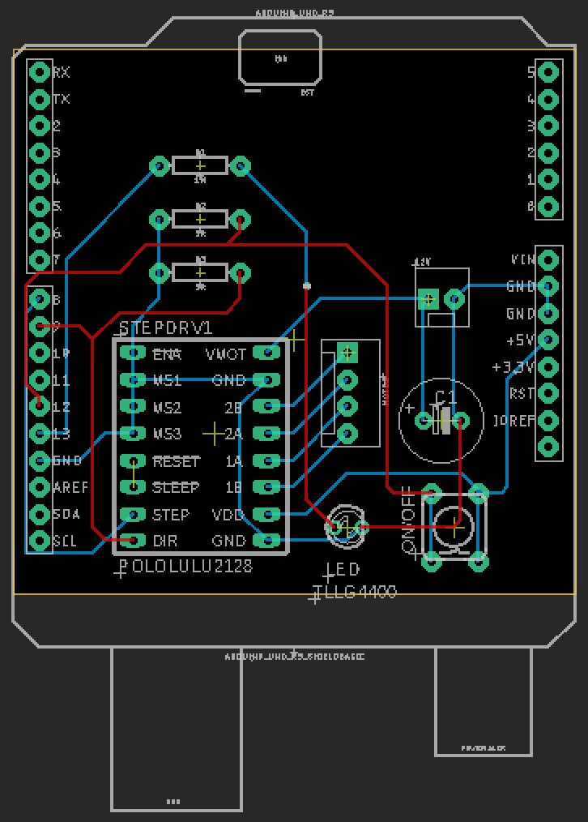

**Figure 2.** Bioreactor Pump PCB Layout

**Tools and Equipment**

|  |  |  |  |  |
| --- | --- | --- | --- | --- |
| **ID** | **Tool** | **Name / # if applicable** | **Location** | **Purpose** |
| PT1 | Printed Circuit Board | N/A | Can be custom ordered by a specialized [company](https://www.4pcb.com) | Houses all electrical components and sits atop of Arduino Uno |
| PT2 | Arduino Uno | N/A |  |  |
| PT3 | Stepper Motor Driver | A4988 | [Gulfcoast Robotics](https://gulfcoast-robotics.com/products/a4988-stepper-motor-driver-module-3d-printer-polulu-stepstick-ramps-reprap-cnc?utm_medium=cpc&utm_source=google&utm_campaign=Google%20Shopping&gclid=CjwKCAjwpqv0BRABEiwA-TySwSMyM69eHqNhPd9kJL6L-Cu937q3-MP5fpvkBBdv6O_dQV9MFcasGxoCAs8QAvD_BwE) | Control/communication between Arduino and Stepper Motor |
| PT4 | Stepper Motor | NEMA17 | [Adafruit](https://www.adafruit.com/product/324) | Controls flow |
| PT5 | Pushbutton | Momentary Pushbutton | [Sparkfun](https://www.sparkfun.com/products/9190) | Toggle stepper motor and LED on/off |
| PT6 | LED | N/A | [Sparkfun](https://www.sparkfun.com/products/12062) | Blinks to indicate circuit function |
| PT7 | Resistor | N/A | [Sparkfun](https://www.sparkfun.com/products/10969) | Provide clean signal |
| PT8 | Capacitor | N/A | [Sparkfun](https://www.sparkfun.com/products/8982) | Provide clean signal |

**Materials**

|  |  |  |
| --- | --- | --- |
| **ID** | **Material** | **Purpose** |
| PM1 | Soldering iron | To mount electrical components onto PCB |
| PM2 | Soldering metal | To mount electrical components onto PCB |

**Computer Files**

|  |  |  |  |
| --- | --- | --- | --- |
| **ID** | **FileName / Link** | **Purpose** | **Location** |
| CF1 | StepperMotorUI_Kishek | To run circuit | /Users/serenakishek/Documents/Spring 2020/Biodesign/Arduino Module/StepperMotorUI_Kishek |

**Appendix:**

The stepper motor datasheet with specifications listed.

